Author of entry: Jap-Nanak Makkar, University of Virginia

Date submitted: June 1, 2015

**Darwish, Mahmoud (1942?-2008)**

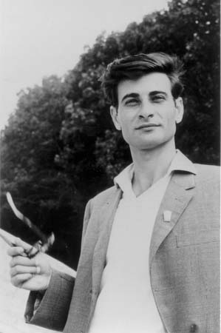

Caption: Mahmoud Darwish in Beirut, Lebanon. Early 1970s.

Copyright: Guardian

URL: http://www.theguardian.com/books/gallery/2008/aug/11/mahmoud.darwish#img-2

Mahmoud Darwish was an internationally honoured Palestinian poet and lifelong advocate for Palestinian nationhood. Born in al-Birwa, Upper Galilee, he was six when Israeli forces occupied and destroyed his village in the midst of the 1948 Arab-Israeli War. Fleeing for a year to Lebanon, his family returned in 1949 to settle in Dier al-Asad as ‘present-absentee aliens,’ a type of refugee status designating that they arrived too late to be included in the Israeli state’s census. Darwish’s status ensured that he was jailed arbitrarily and subject to heavy travel regulations until he left Israel in 1970, at which time he accepted a university scholarship at the Academy of Social Sciences in Moscow. In 1971, he began work at the daily newspaper *Al-Ahram* in Cairo, Egypt, and from 1973 to 1982, he worked in Beirut, Lebanon, in close association with the Palestinian Liberation Organization as well as its Center for Palestine Studies. During his mature years, he founded and edited *Al-Karmel*, an esteemed literary journal; fled from Beirut after the 1982 Israeli invasion of Lebanon, entering exilic life in Tunis and later Paris; wrote the Palestinian Declaration of Independence in 1987; and resigned from the PLO in protest of the Oslo Accords. From 1996 until his death in 2008, he lived intermittently in Ramallah, West Bank, where he edited *Al-Karmel* and ran the Carmel Cultural Organization.

During his lifetime, Darwish garnered recognition as the national poet of the Palestinian people. Along with Smih al-Qasim, Tawfiq Ziyad and Sallim Jibran, Darwish represents the modernization of Palestinian poetry, a shift characterized by the use of vernacular diction, short lines and political sentimentality. His work was shouted at rallies, translated into 24 languages, and reprinted numerous times. In Edward Said’s *Culture and Imperialism,* he was discussed as a poet of decolonization. The French government awarded him the *Ordre des Arts et des Lettres* in 1997.

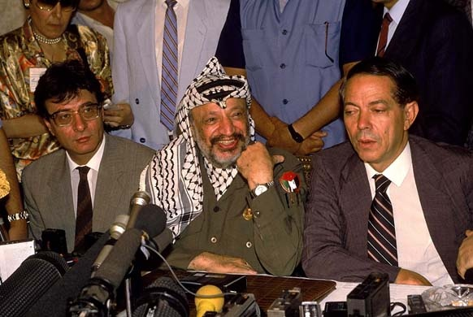

Caption: Darwish, at left, sitting beside PLO chairman Yassar Arafat and Egypt’s Osama al-Baz, at right.

URL: http://www.theguardian.com/books/gallery/2008/aug/11/mahmoud.darwish#img-3

Copyright: Barry Iverson/Getty Images

In addition to his ability to use and modernize the canon of Palestinian poetry, Darwish showed a familiarity with ancient and modern Israeli texts. Using figures from the Hebrew Bible, and writing under the influence of Hayyim Bialik and Yehuda Amichai, Darwish frequently commented on the shared mythologies, history and geography between the Palestinians and Israelis. He acknowledged the influence, also, of Federico García Lorca and Vladimir Mayakovski.

**Selected List of Works**

**Poetry**

أوراق الزيتون (1964, “Leaves of Olive”)

عاشق من فلسطين (1966, “Lover from Palestine”)

آخر الليل (1967, The End of the Night)

العصافير تموت في الجليل (1969, “Birds are Dying in Galilee”)

حبيبتي تنهض من نومها (1970, “My Beloved Leaves Her Bed”)

أحبك أو لا أحبك (1972, “I Love You / I Love You Not”)

7 محاولة رقم (1973, “Trial Number 7”)

تلك صورتها وهذا انتحار العاشق (1975, “That’s Her Image and This is the Lover’s Suicide”)

أعراس (1977, “Weddings”)

مديح الظل العالي (1983, “Praise to the High Shadow”)

حصار لمدائح البحر (1984, “A Siege for the Sea Eulogies”)

هي أغنية, هي أغنية (1984, It’s a Song, It’s a Song)

ورد أقل (1986, “Fewer Roses”)

أرى ما أريد (1990, “I See What I Want to See”)

أحد عشر كوكباً (1992, “Eleven Planets”)

لماذا تركت الحصان وحيدا (1995, translated *Why Did You Leave the Horse Alone?* [2006])

سرير الغريبة (1998, “A Bed of the Stranger”)

جدارية (2000, translated *Mural* [2009])

حالة حصار (2002, translated *A State of Siege* [2010])

لا تعتذر عما فعلت (2003, “Don’t Apologize for What You’ve Done”)

كزهر اللوز أو أبعد (2005, translated *Almond Blossoms and Beyond* [2009])

**Prose**

ذاكرة للنسيان (1987, translated *Memory for Forgetfulness* [1995])

في حضرة الغياب (2006 translated *In the Presence of Absence* [2011])

**Edited English Translations**

*The Music of Human Flesh* (1980)

*The Adam of Two Edens: Selected Poems* (2000)

*This Raven’s Ink* (2001)

*Unfortunately It was Paradise*(2003)

*The Butterfly’s Burden: Poems* (2007)

*If I Were Another* (2009)

*A River Dies of Thirst* (2009)

**References and Further Reading**

Said, Edward (1994) “On Mahmoud Darwish,” *Grand Street* 48: 112-115.

Mattawa, Khaled (2014) *Mahmoud Darwish: The Poet’s Art and his Nation*, New York: Syracuse University Press.

Nassar, Hala Khamis, Najat Rahman (eds.), (2008) *Mahmoud Darwish, Exile’s Poet: Critical Essays*, Northampton, Mass.: Interlink.

Yeshurun, Heilit. (2012) “Exile is So Strong Within Me, I may Bring it to the Land: A Landmark Interview with Mahmoud Darwish,” *Autumn* 42.1: 46-70.